Practical no. 6
Name :- Danish Altaf Solkar Enrolment no. :-24111590805
Class :- CO3K – B Subject :- DMS
Aim:- Execute TCL commands to manage database using SQL

QUERY :- CREATE TABLE STUD(Name VARCHAR2(10),Age NUMBER(2),RollNo NUMBER(3));
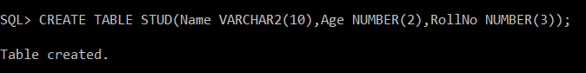
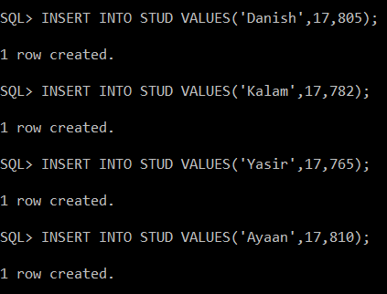

QUERY :- COMMIT;
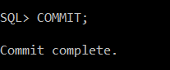

QUERY :- SAVEPOINT A;
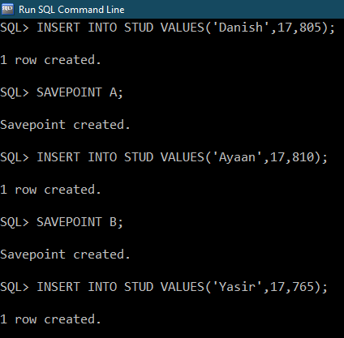

QUERY :- ROLLBACK TO A;
